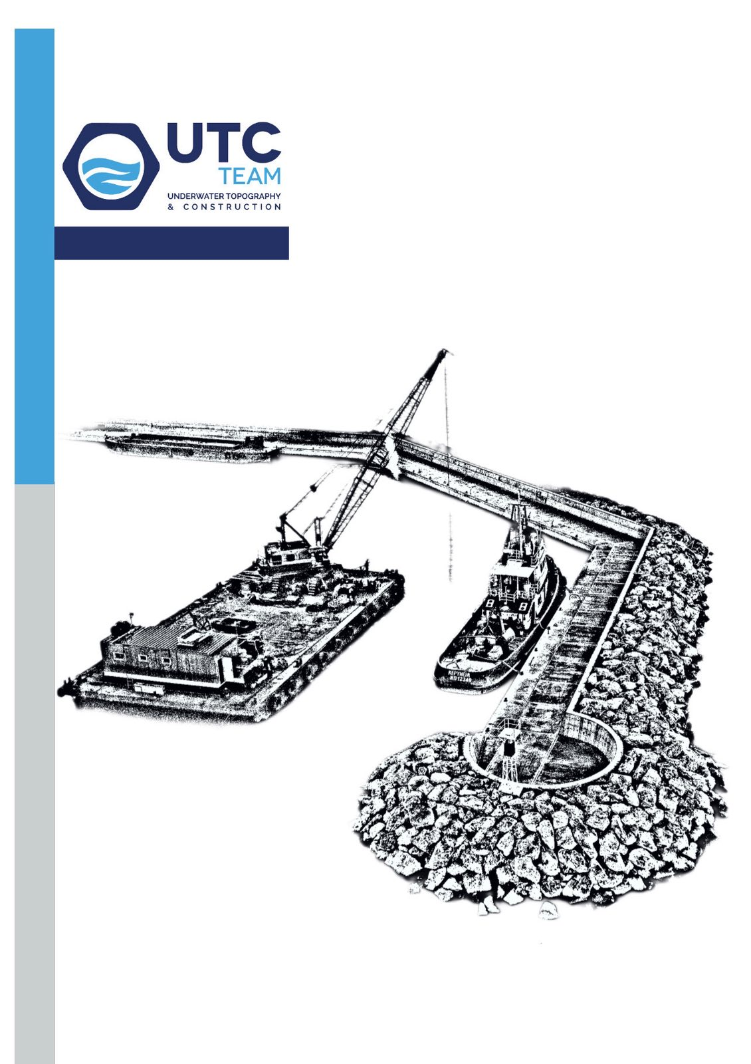

Table of Contents

Who we are ………………………………………………………………….………….………….……2
Our Philosophy …………………………………………………………………….…………..……...2
Methodologies- tools- means and techniques ……..…………..……………………...3
Equipment- Vessels …………………………………………………….……………….……...5-11
Projects ………………………………………………………….……………………..………..…12-27



WHO WE ARE

UTC TEAM is a Greek engineering and construction company specializing in port and marine infrastructure. Established in 2017, the company builds on the long-standing individual and collective entrepreneurial activities of its shareholders, whose track record in the sector dates back to 2001.

With over 20 years of exclusive experience in port construction, we have developed in-depth knowledge of the challenges posed by the marine environment. This expertise enables us to consistently deliver high-quality projects, meet demanding schedules, and respond effectively to the needs of our clients.

Driven by our specialized workforce and extensive know-how, UTC TEAM is a dynamically growing company that has secured a strong and distinctive position in the Greek market for port and marine works.

OUR PHILOSOPHY

At the heart of our philosophy lies a simple belief: every project deserves a unique approach. By tailoring our solutions to the specific needs of each location, we ensure results that truly stand out. With a commitment to professionalism and a deep respect for our clients’ timelines, we don’t just deliver projects — we deliver trust, quality, and lasting value.
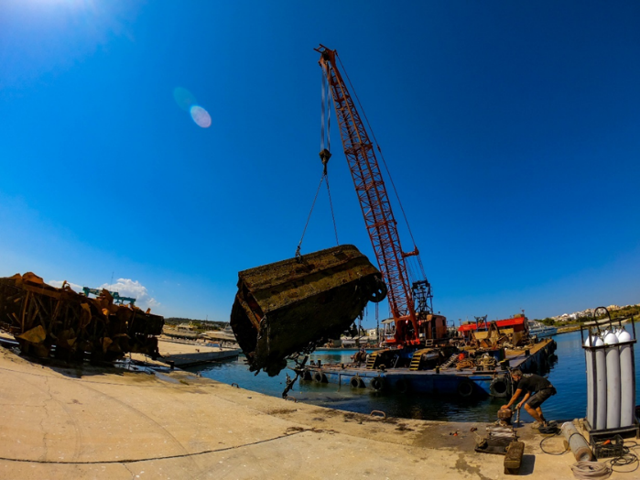
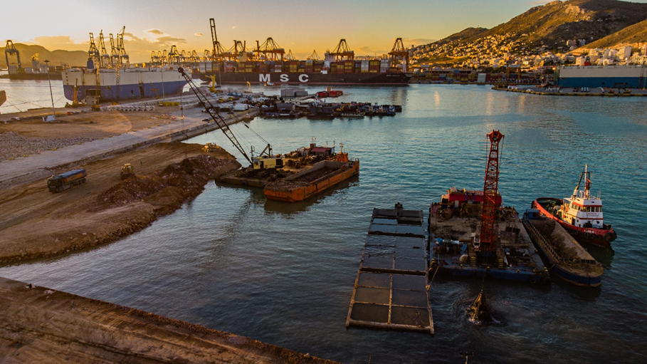

METHODOLOGIES - TOOLS - MEANS AND TECHNIQUES

The company is ISO certified for the construction of private and public technical works and the implementation of hydrographic and diving services. It also has an Environmental Management System Certificate according to ISO 14001, Road Traffic System (RTS) according to ISO 39001 as well as an Occupational Health and Safety Management System Certificate according to OHSAS 45001.
The company is particularly sensitive regarding environmental issues and believes that every project should contribute to sustainable development.

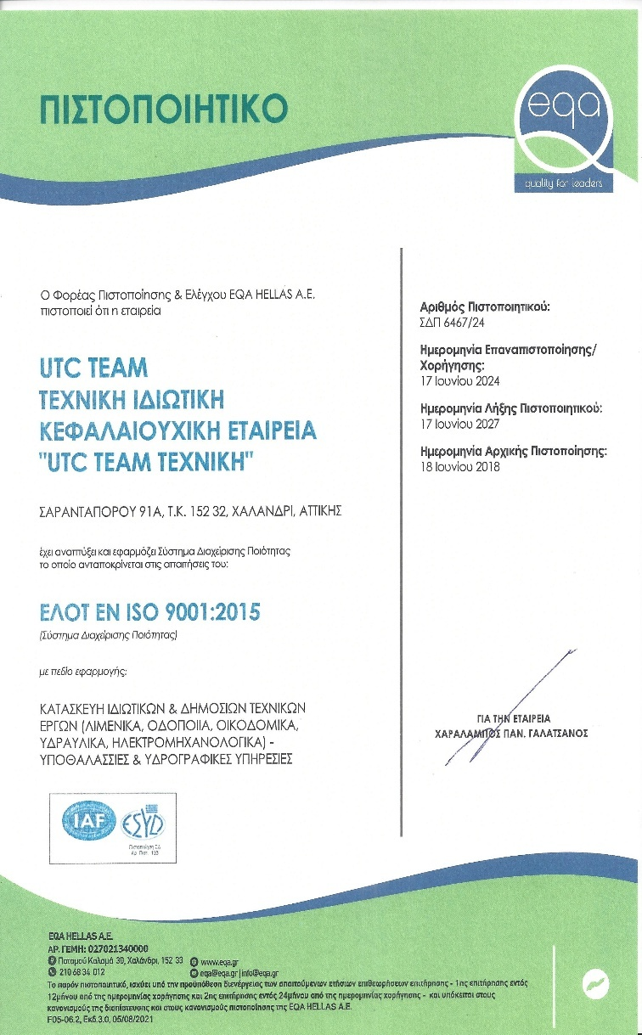

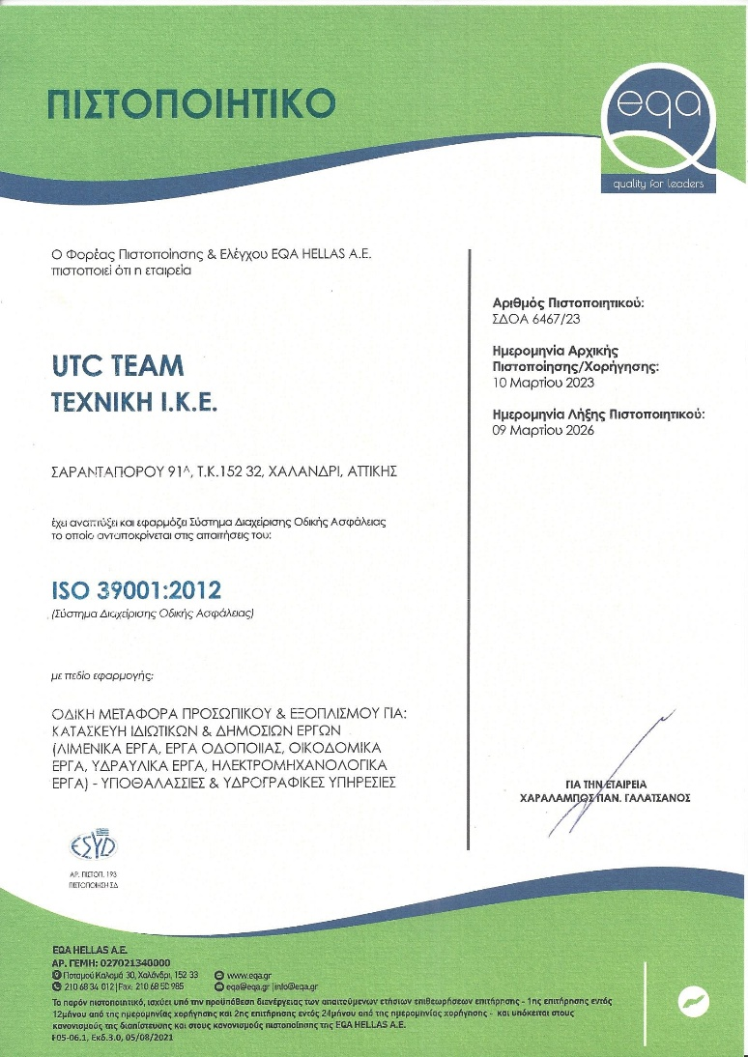

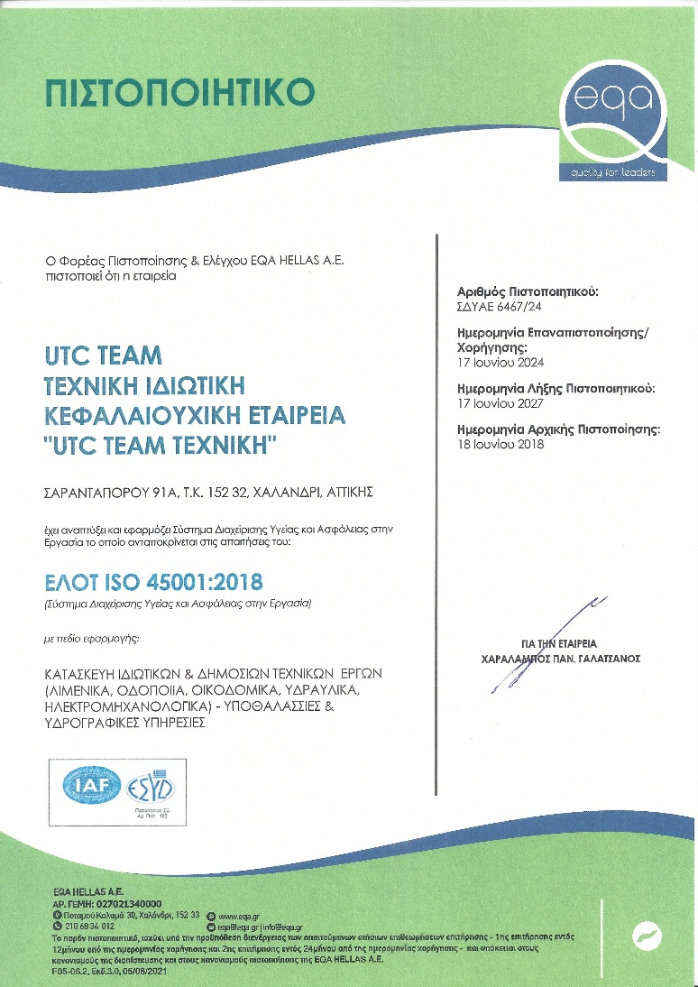

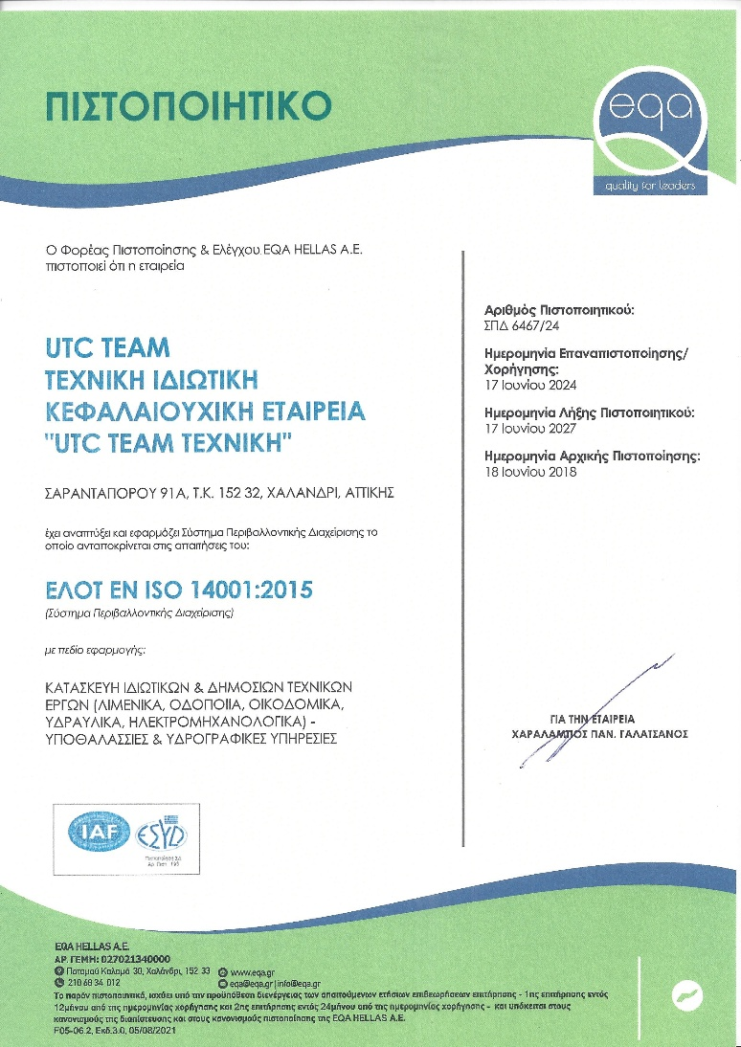
EQUIPMENT- VESSELS
UTC TEAM is equipped with a comprehensive range of specialized machinery and vessels that ensure the successful execution of complex port and marine projects. Our fleet includes:

- Tugboats
- Floating cranes
- Barges
- Loaders and heavy machinery

This advanced mechanical equipment, combined with our skilled personnel, enables us to operate efficiently under challenging marine conditions and deliver projects of the highest standards.

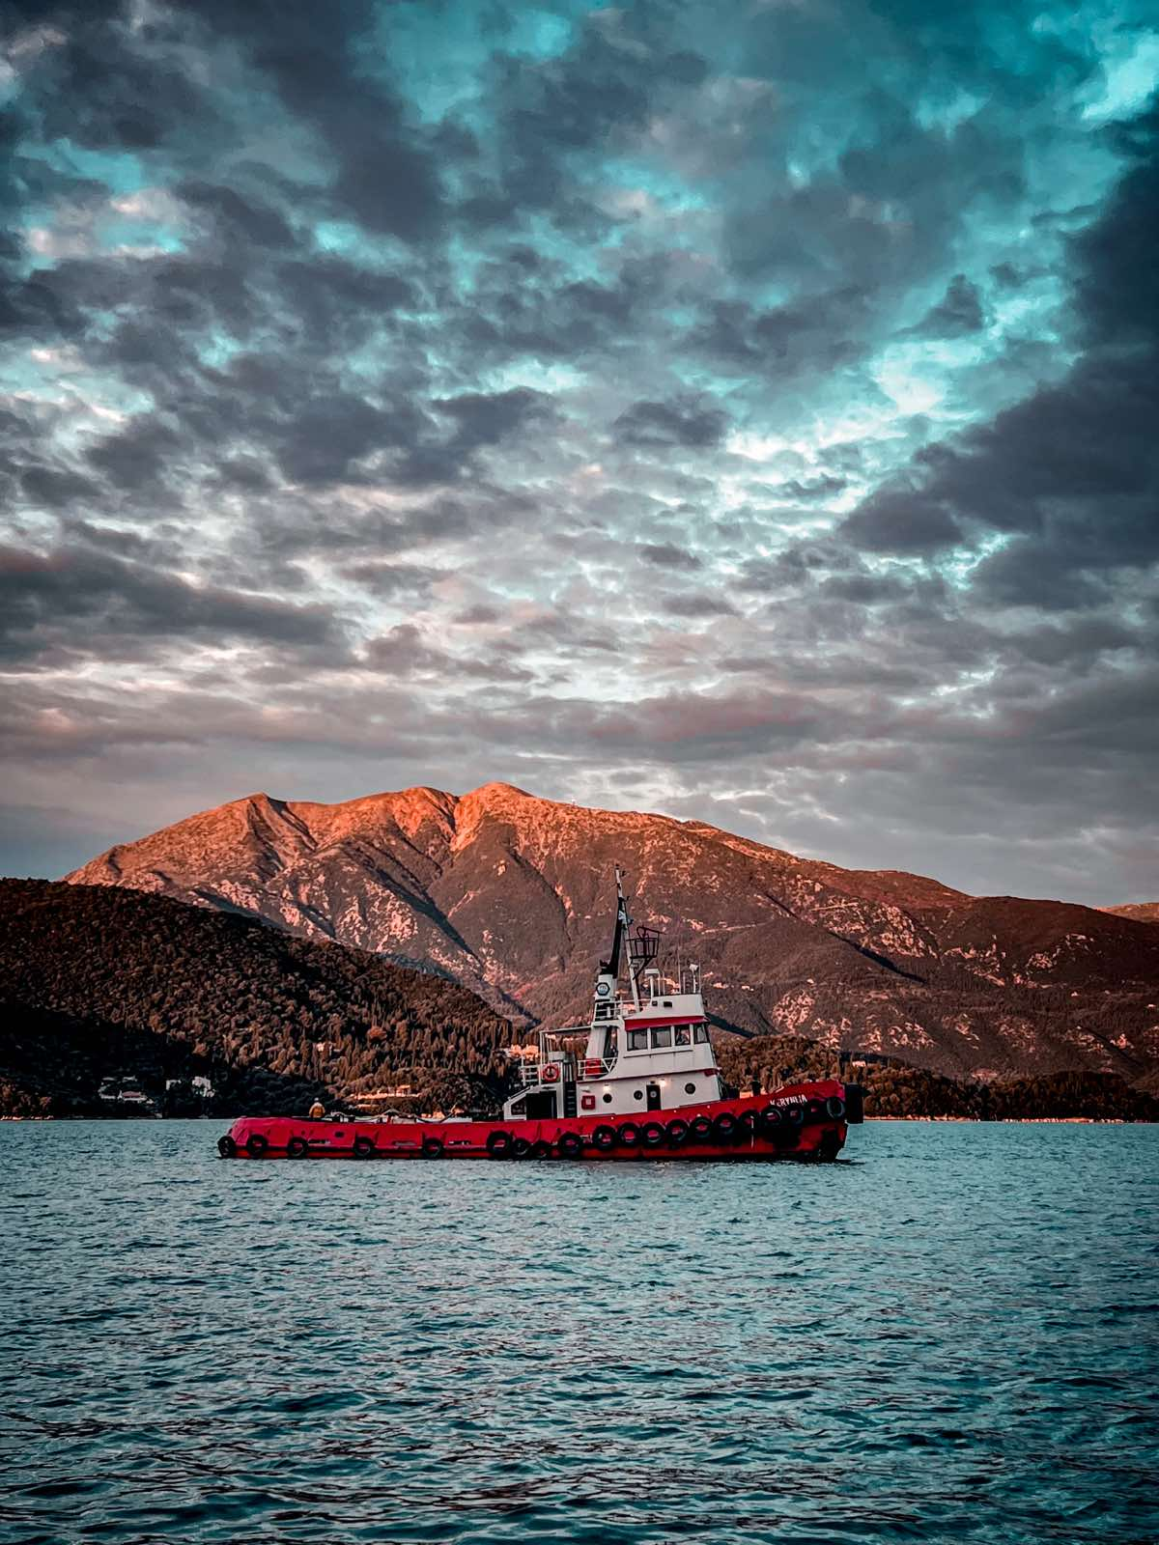
T/B KERYNEIA

Characteristics

Type of vessel | TUG BOAT
Register number | Piraeus 12349
IMO | 7943108
Flag | Greece
Overall length | LOA = 28.23m
Overall breadth | Bmax = 7.32m
Depth | dmax = 3,40m
Gross tonnage | 120
Net tonnage | 36
Main engines | 2 RUSTON VEBXM
Horse power | 2x498
Propulsion | 2 propellers
Accommodation | 5 persons
Video link | https://www.youtube.com/watch?v=Rybc1TmAA2s

Τ/Β ACHILLEAS
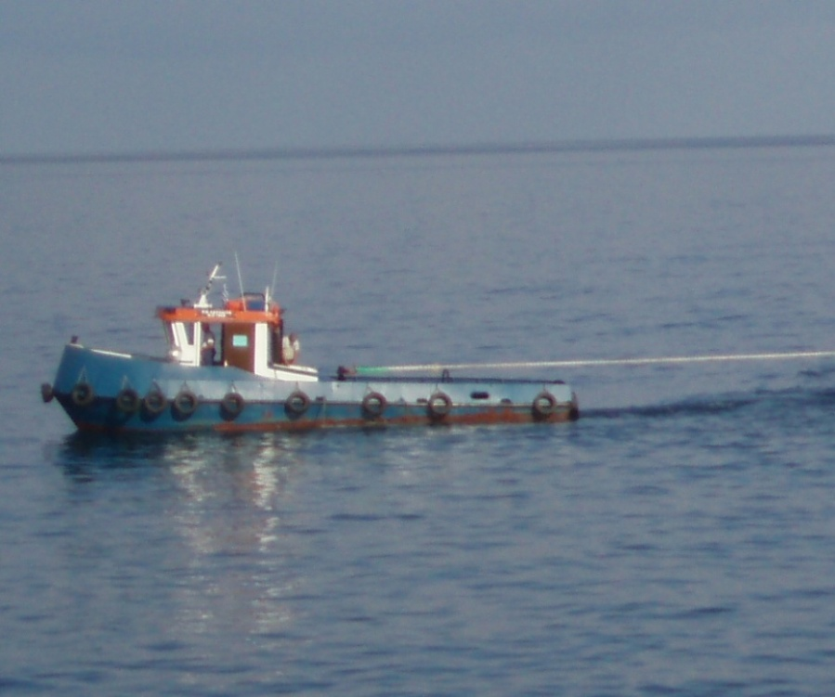

Characteristics

Type of vessel | TUG BOAT
Register number | Pireaus 7968
Flag | Greece
Overall length | LOA = 13.25m
Overall breadth | Bmax = 3.45m
Depth | D = 2,60 m
Gross tonnage | GT=16.52
Net tonnage | NT=6.26
Main Engine | CUMMINS NTC 355 BHP
Propulsion | 1 Propeller

C/B CHRYSOULA
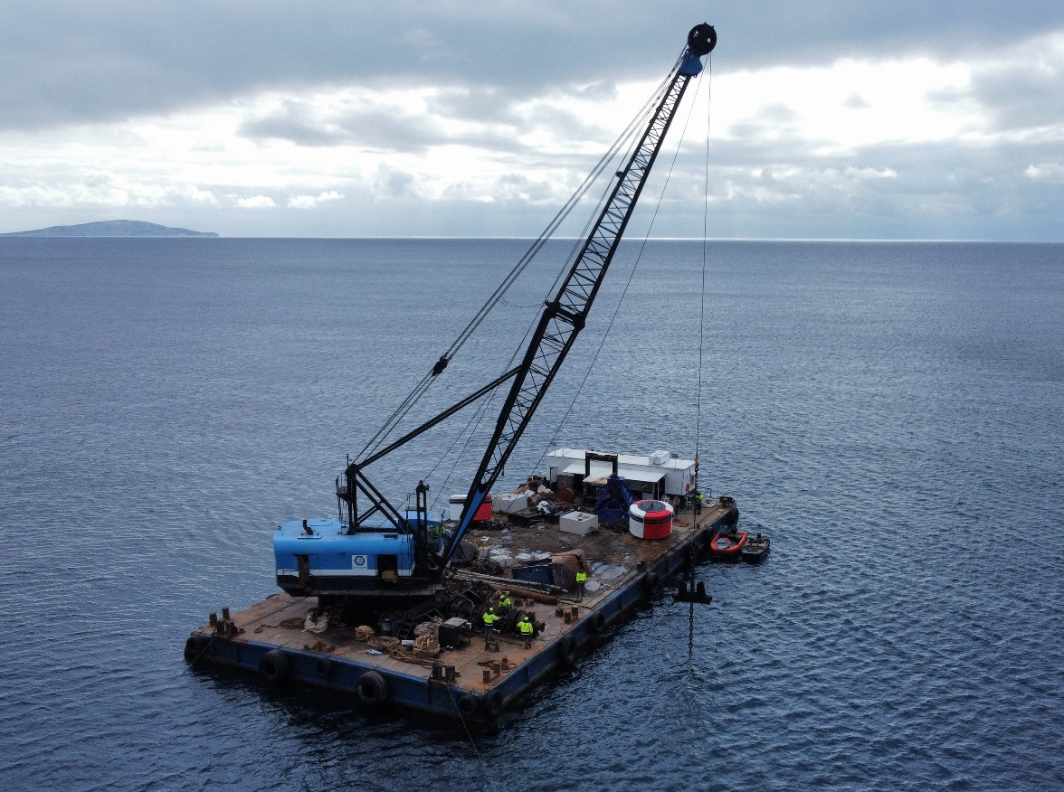

Characteristics

Type of vessel | Crane Barge
Register number | Piraeus 196
Flag | Greece
Length | 40.10m
Breadth | 18m
Depth | 1.2m
Net Tonnage | 687.63
Gross Tonnage | 695.02
Crane | LIMA 2400B
Lifting Capacity | 100tn
Accommodation | 2 cabins/6 persons
Video link | https://www.youtube.com/watch?v=pdvPC5hmOw4

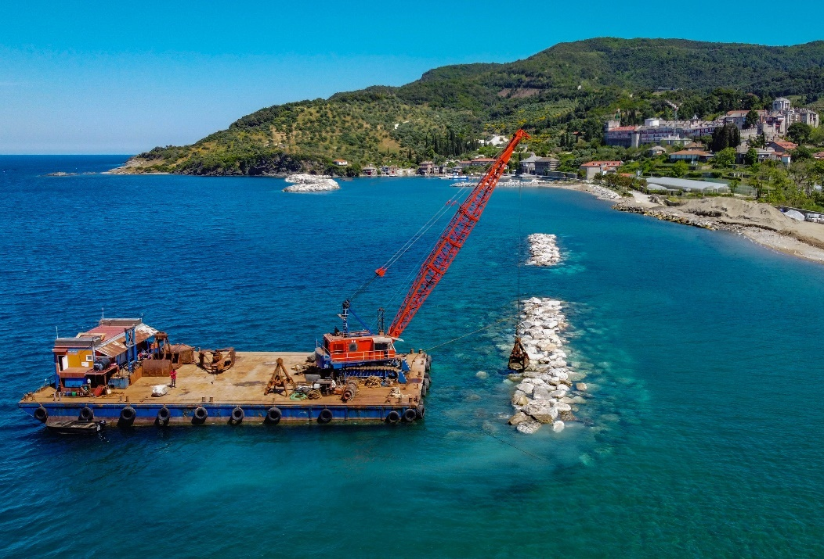
C/B MARINOS

Characteristics

Type of vessel | Crane Barge
Register number | Piraeus 2556
Flag | Greece
Length | 33.00m
Breadth | 17.06m
Depth | 2.25m
Net Tonnage | 320.45
Gross Tonnage | 359.64
Crane | NCK 1405D
Lifting Capacity | 70tn
Accommodation | 2 cabins/4 persons
Video link | https://www.youtube.com/watch?v=9Xlg6r14Y-k&t=1s

S/B VASILIKI
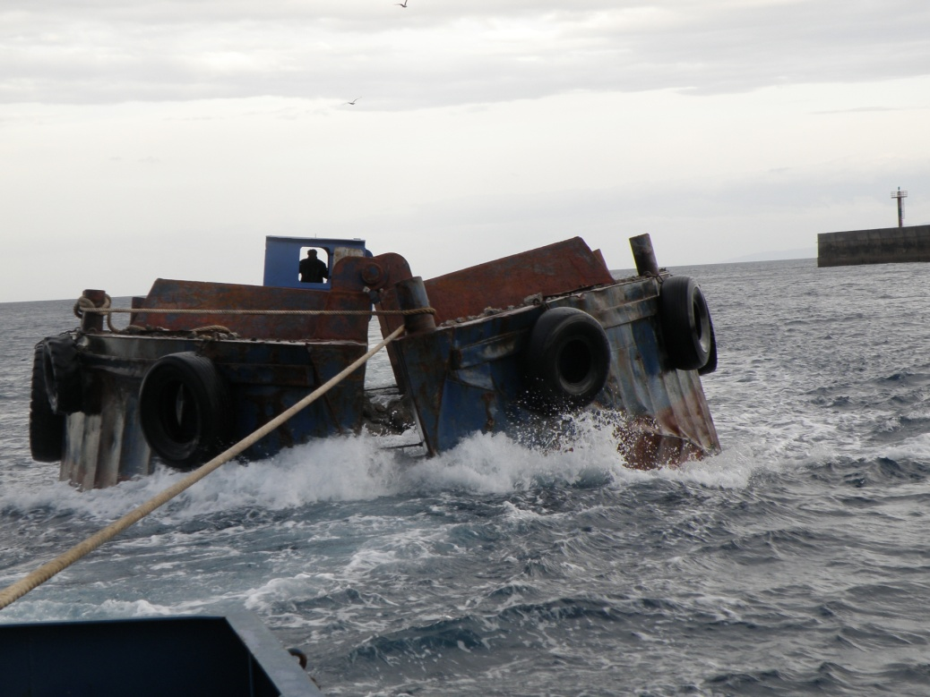

Characteristics

Type of vessel | Split barge
Register number | Pireaus 2491
Flag | Greece
Length | 31,75m
Breadth | 6,5m
Depth | 2,3m
Gross tonnage | 159,35
Net tonnage | 159,35
Engines | Without propulsion engines

DECK BARGE PEIRAIAS VI
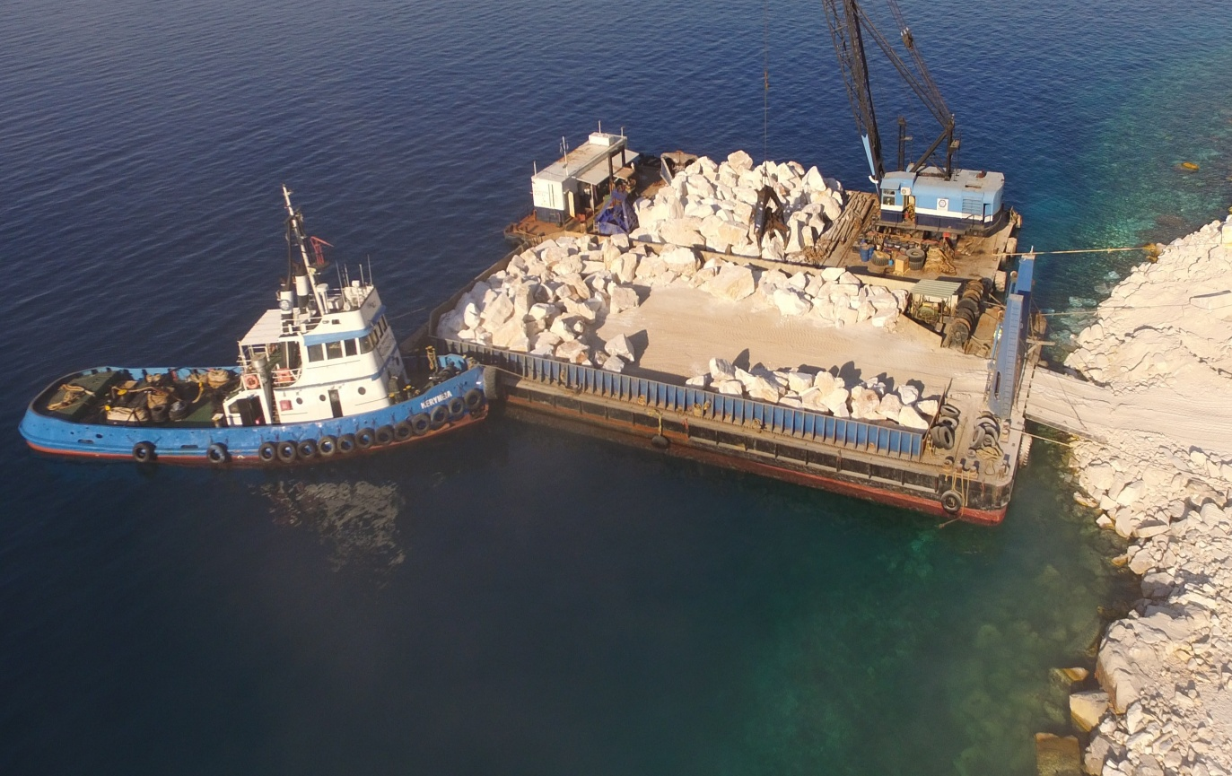

Characteristics

Type of vessel | Deck barge
Register number | Pireaus 164
Flag | Greece
Length | 40,34m
Breadth | 19,34m
Depth | 2m
Gross tonnage | 687,24
Net tonnage | 673,14
Engines | Without propulsion engines

PROJECTS
-Major Projects:

Project name: Upgrade and Expansion of the existing port Infrastructure of Panayitsa Pier and Underwater Pipe Relocation
Place: Skorpios Island, Lefkada
Budget: 1,816,124.00 €
Customer: MYKINAI SA
Execution period: 2022-2023
About the project: A highly demanding marine infrastructure project on the legendary Skorpios Island, involving the construction of new marinas in the Panagitsa area. The works included the construction of a 100m quay with external armor protection, as well as the installation of a new water pipeline. This development forms a key part of Russian investor Dmitry Rybolovlev’s major transformation of the island into a world-class luxury resort, enhancing both functionality and prestige.

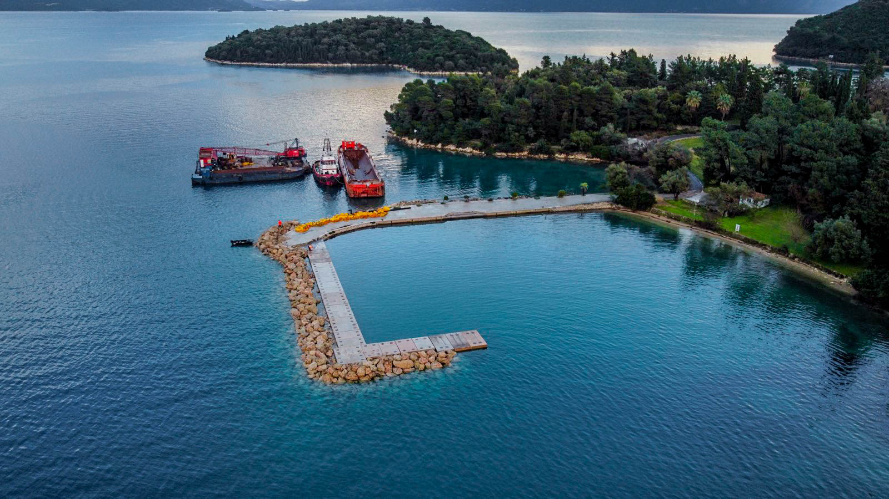

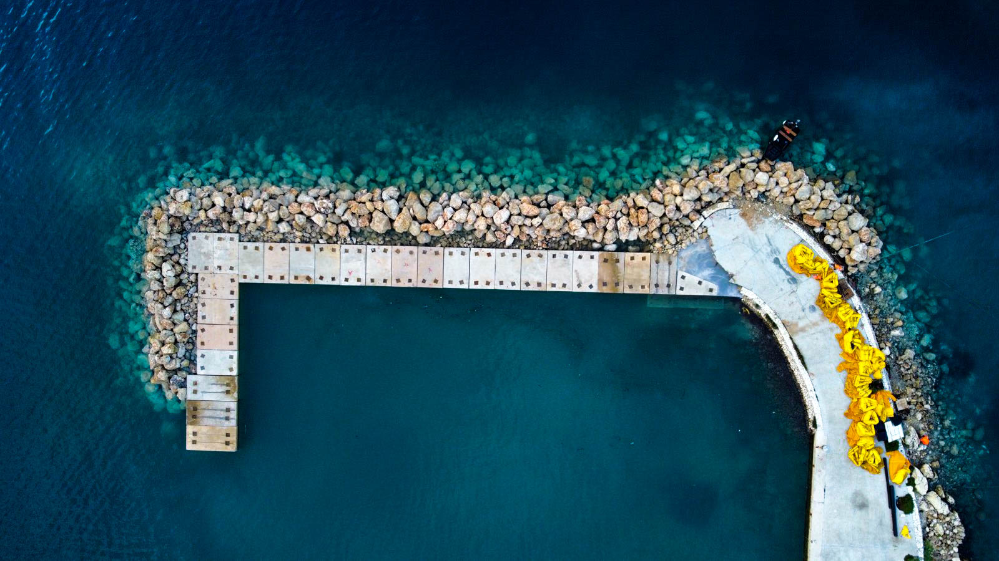
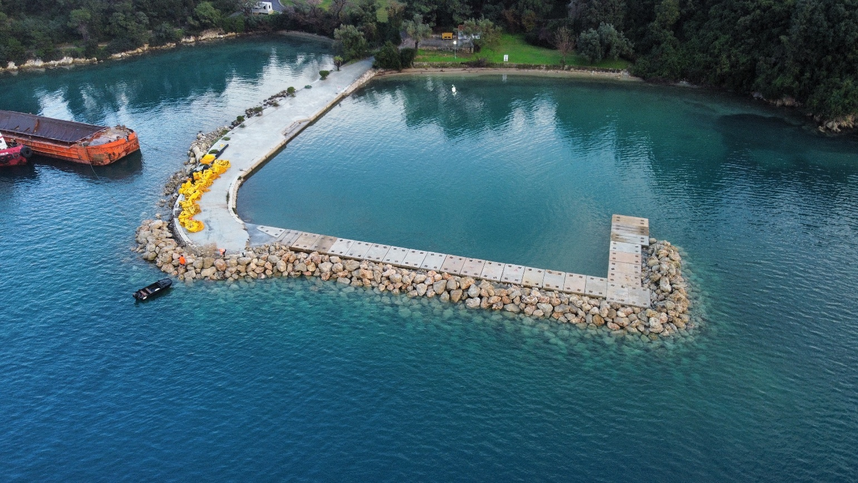

Project name: Tourist Marina Shelter – ESHADA of Agios Ioannis, (AMMOA hotel & SPA)
Place: Nikiti Chalkidiki, Greece
Budget: 1.412.903,00€
Customer: TEKAL SA
Execution period: 2023-2024
About the project: Development of Marina Infrastructure for 45 yachts. Dredging of the harbor basin and construction of a 180-meter quay wall with protective wall and a 180-meter breakwater
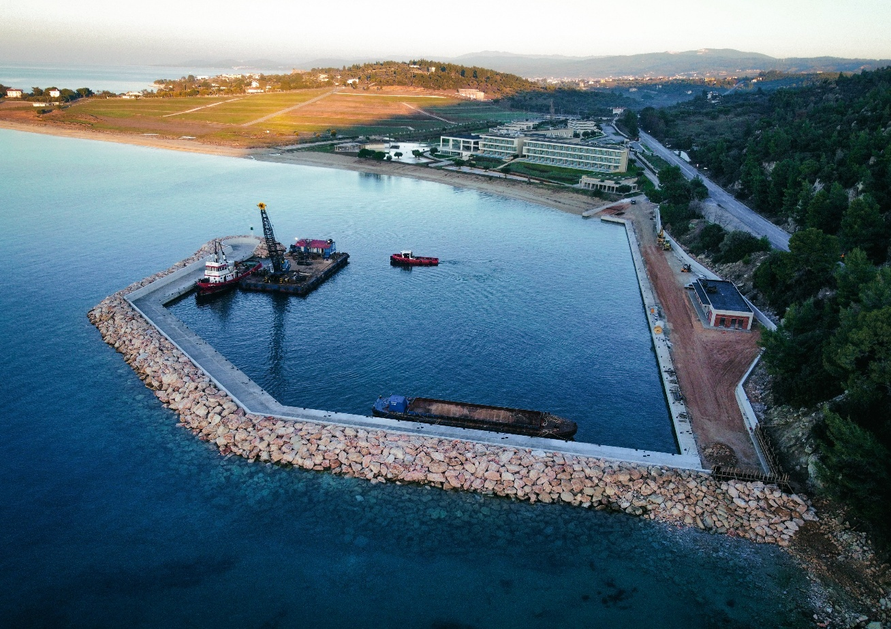

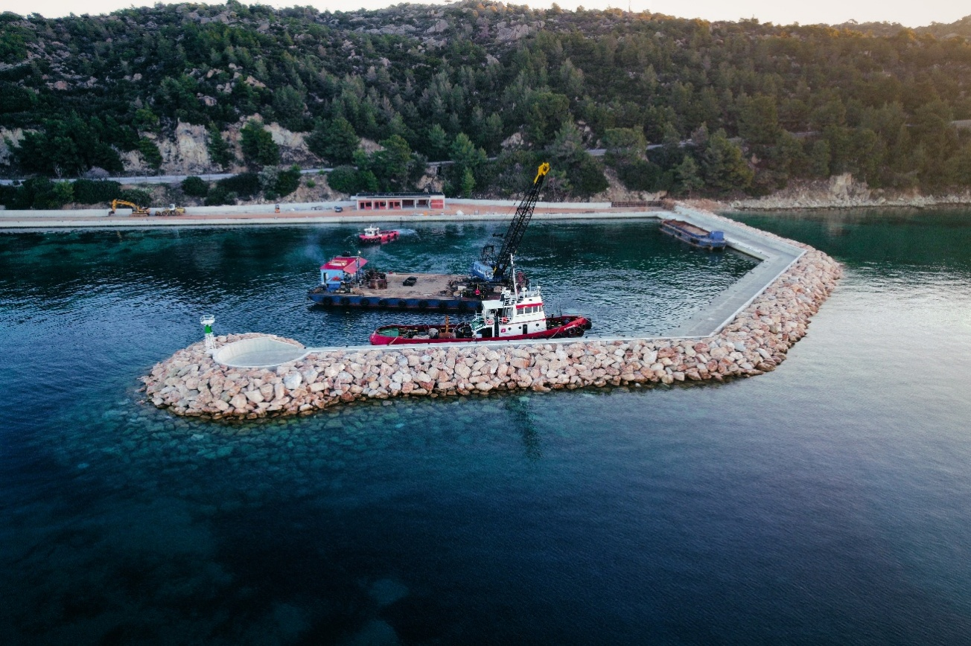

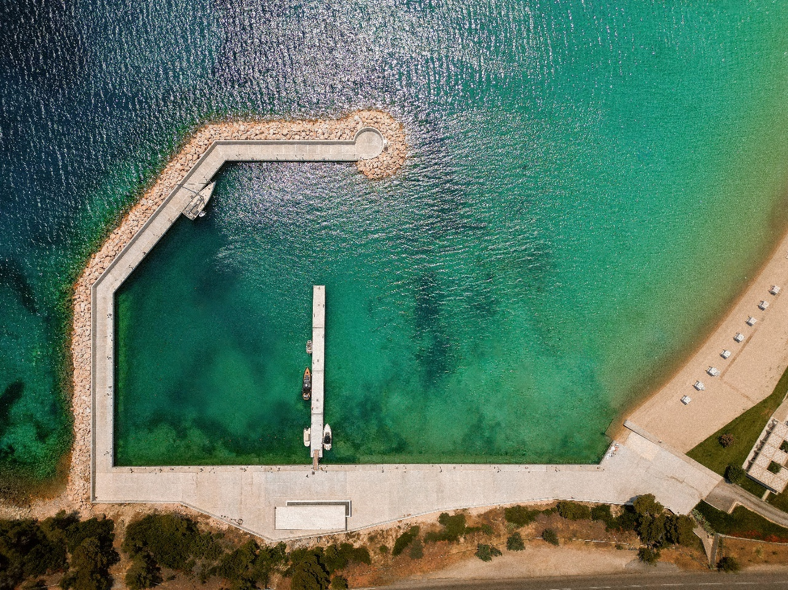

Project name: Maritime Infrastructure of the Holy Monastery of Iviron
Place: Agion Oros, Greece
Budget: 5.741.330,36 €
Customer: Ergomare SA
Execution period: 2024-today
About the project: Construction of a 240 m breakwater with natural rock armor and rockfill foundation. Extension of the existing pier by 165 m in total length, and widening of its core structure.
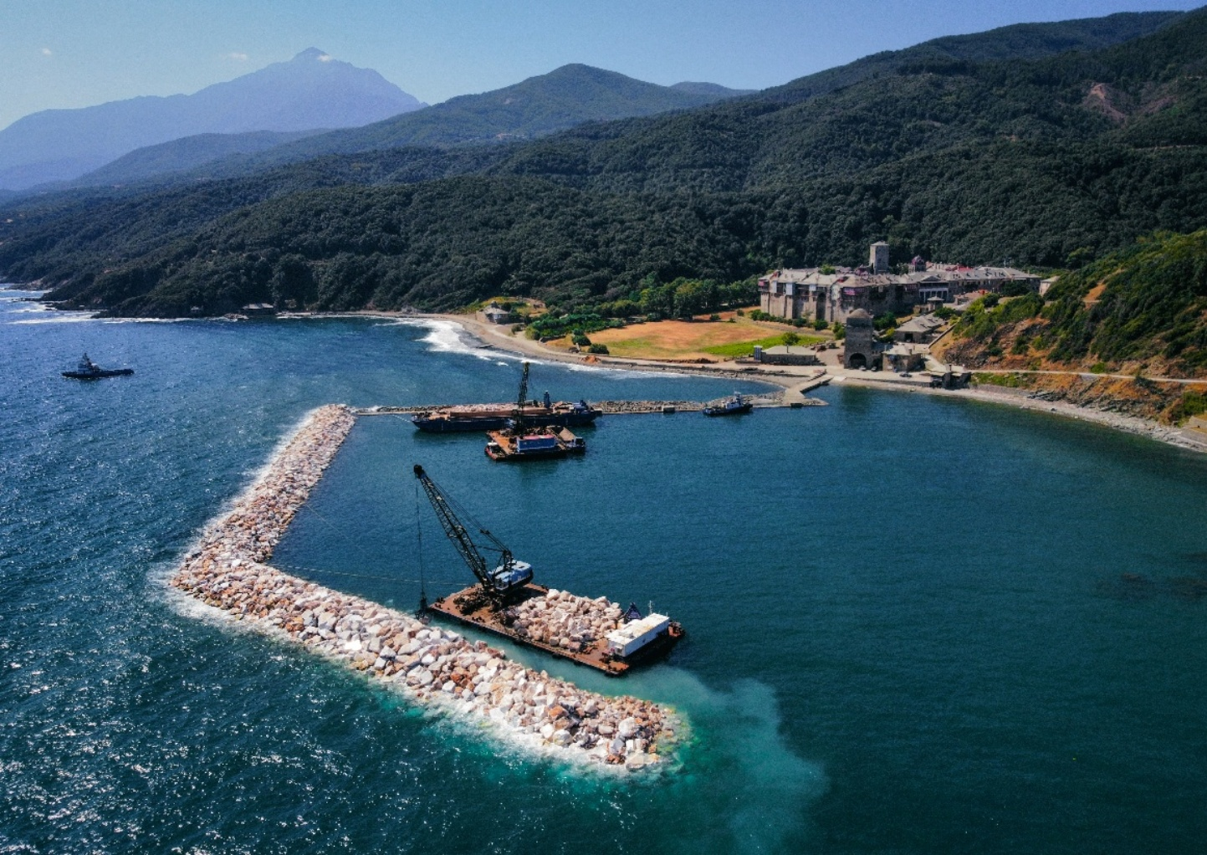

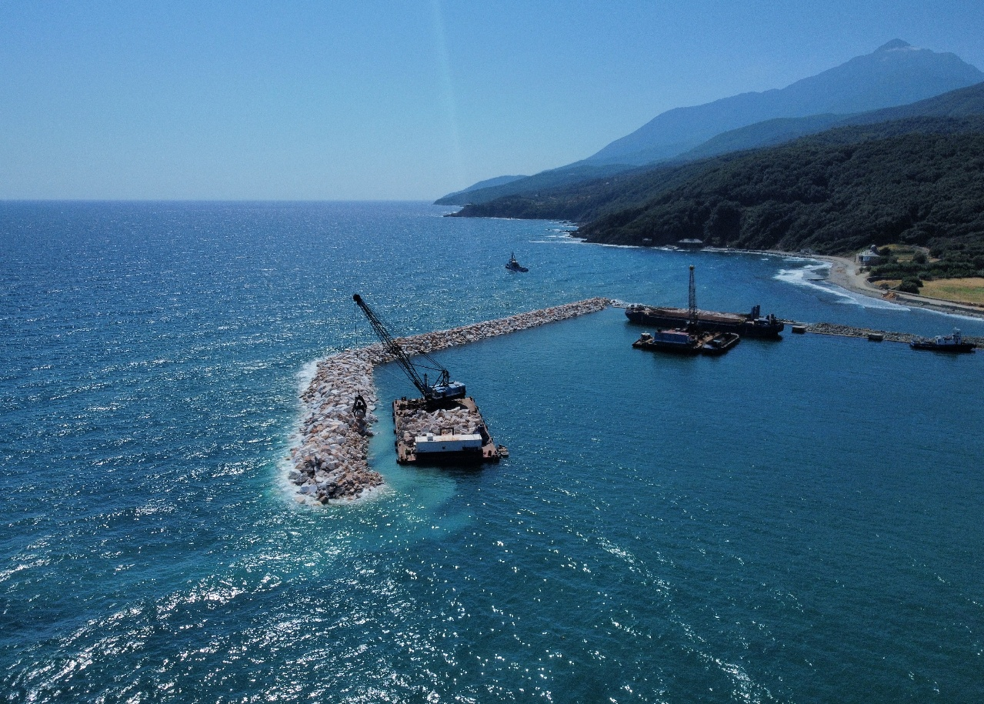

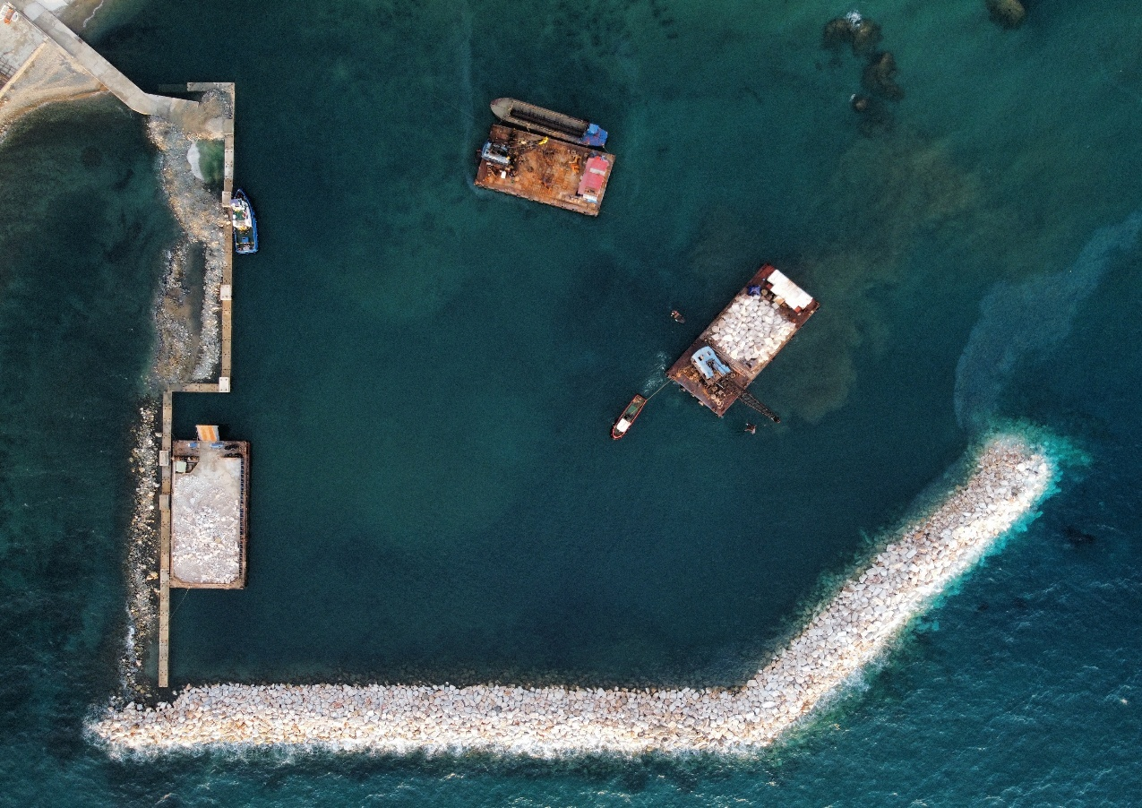

Project name: Pier of the Port of the Holy Monastery of Great Lavra
Place: Agion Oros, Greece
Budget: 7.365.509,64€
Customer: Monastic community of Holy Mountain
Execution period: 2025-today
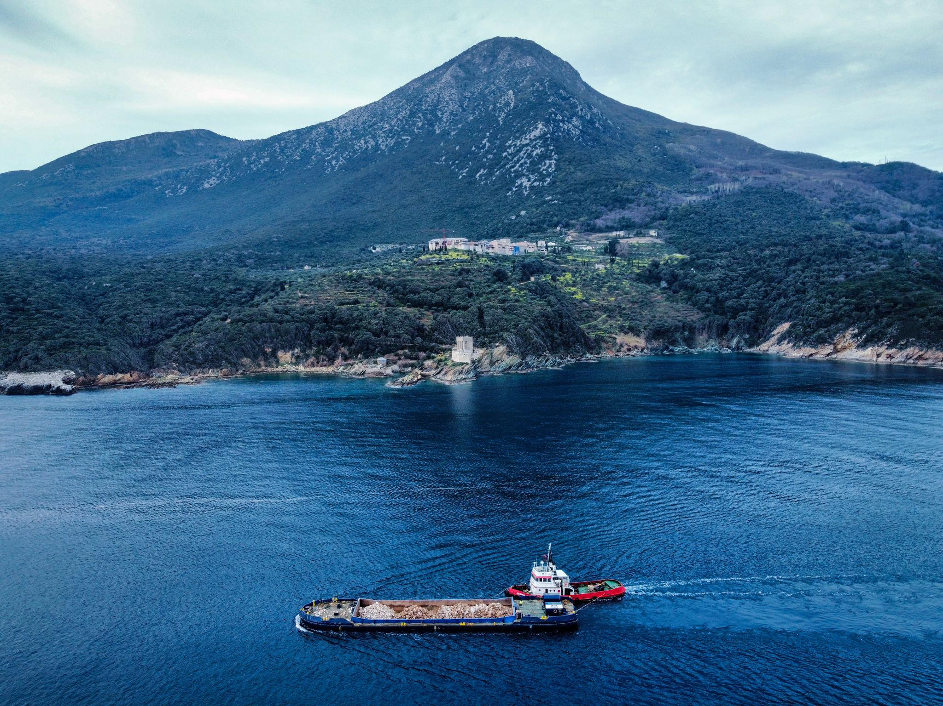
About the project: Construction of a breakwater 122 m long, and construction of a quaywall 230m long. Construction of an access road and a vehicle bridge connecting the access road with the quaywall.

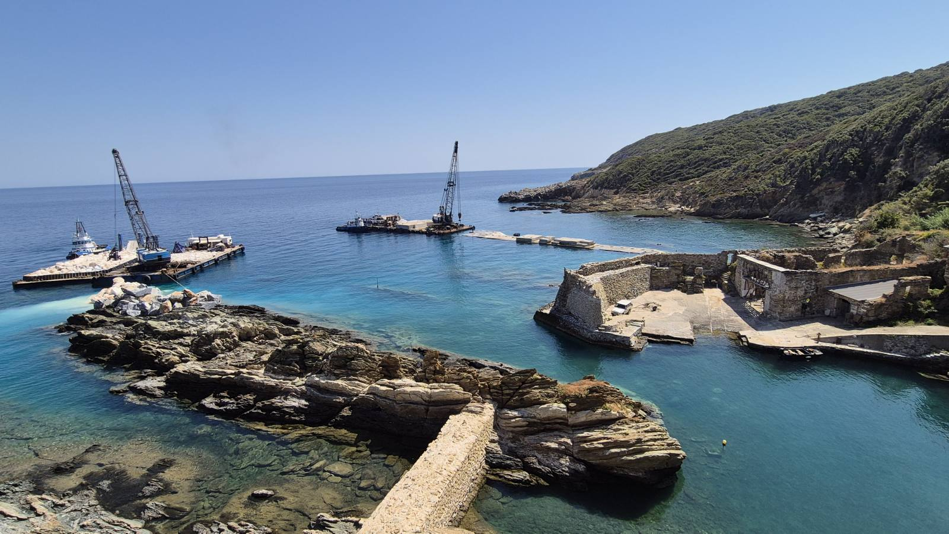

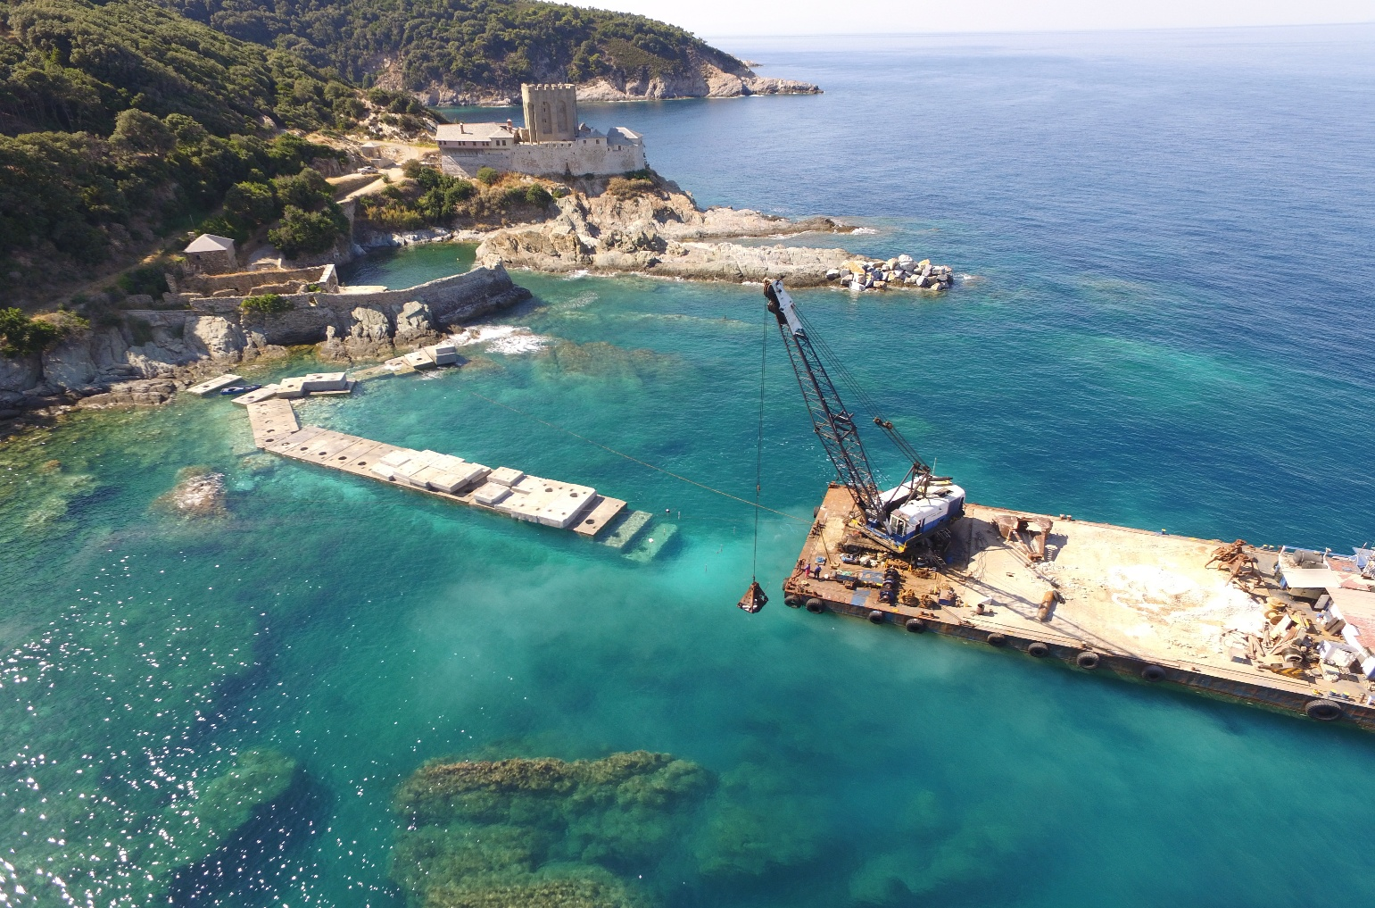

Project name: Modernization of the mooring facilities of the 135 Combat Wing
Place: Skyros, Greece
Budget: 687.474,85
Customer: Ministry of Defense
Execution period: 2025
About the project: Replacement of old mooring buoys with new mooring buoys for tying up and anchoring
Fuel vessels, and replacement of the old fuel pipe with a new steel pipe with a total length of 312m.

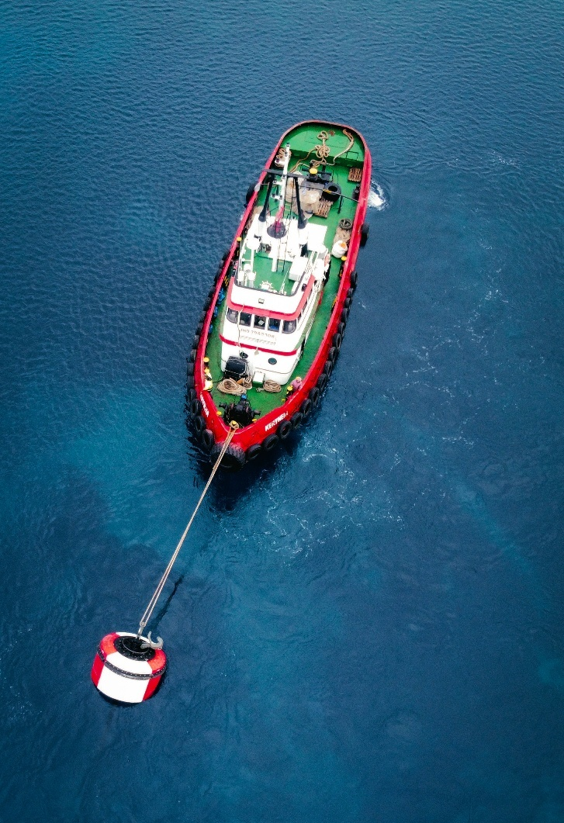
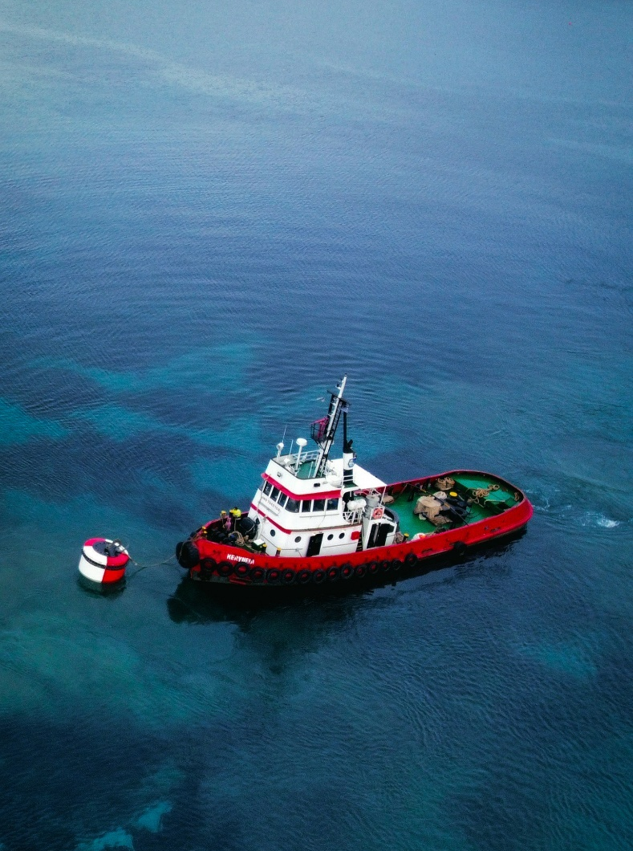

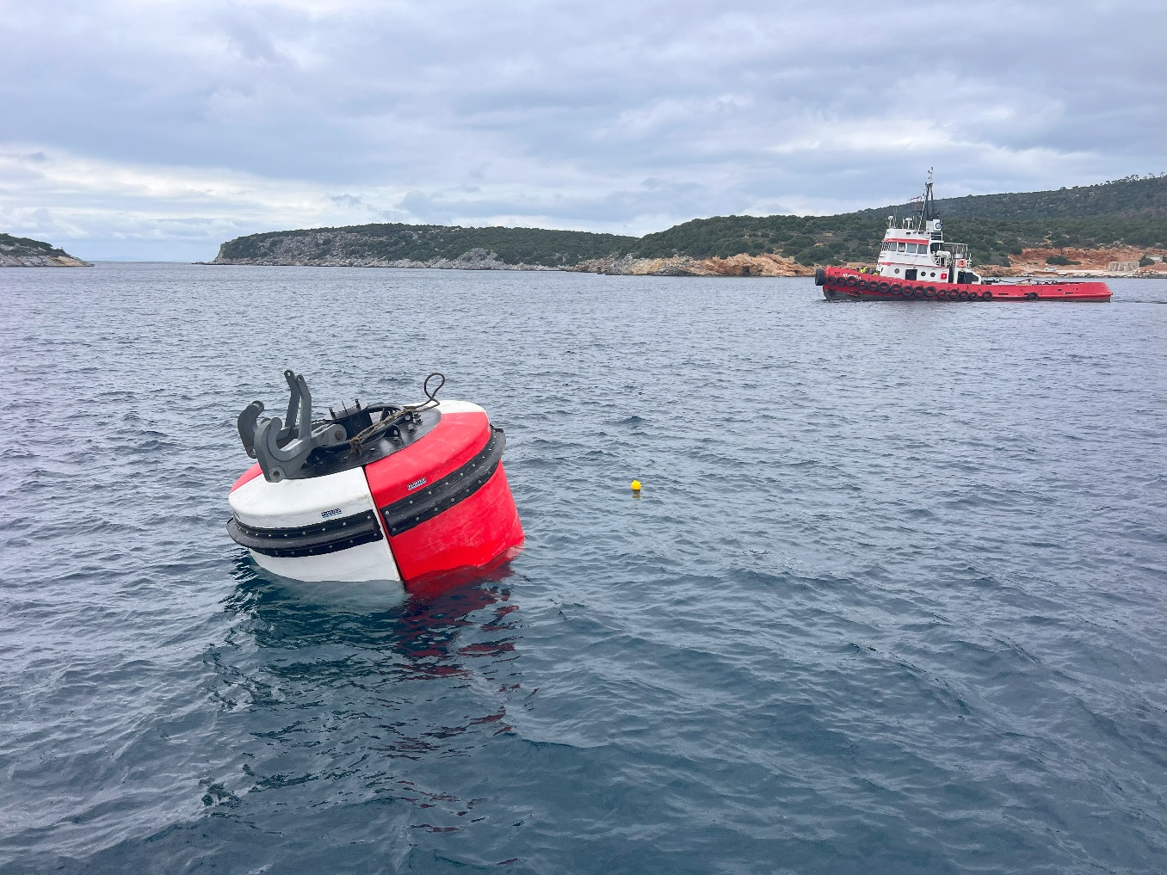

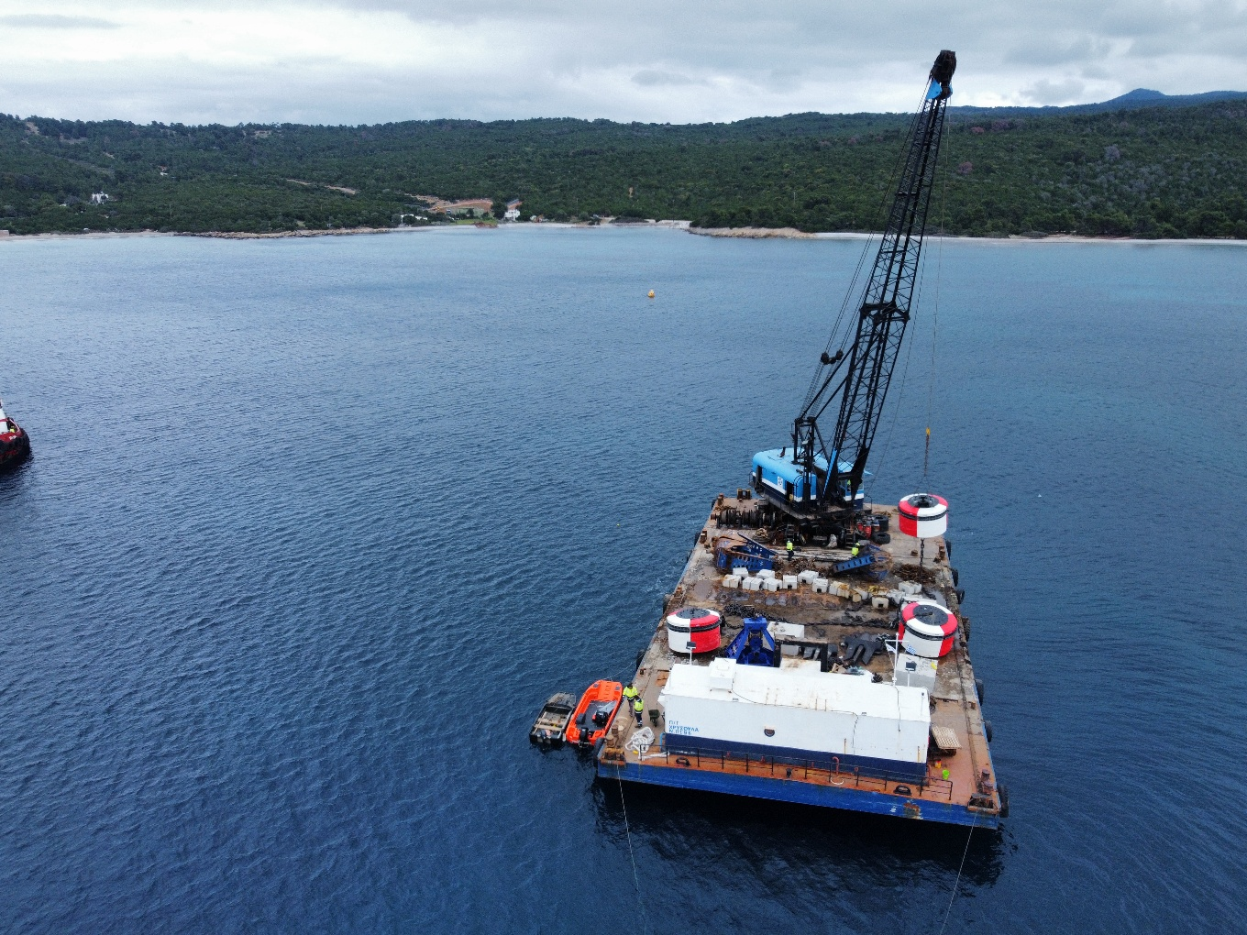

Project name: Construction of a fishing boat shelter in Xylokeratidi, Katapola, Amorgos Island
Place: Xilokeratidi Amorgos, Greece
Budget: 1,725,806.00 €
Customer: Municipality of Amorgos
Execution period: 2020-2021
About the project: Construction of a 140 m windward breakwater with inner quay wall and outer rock armor.

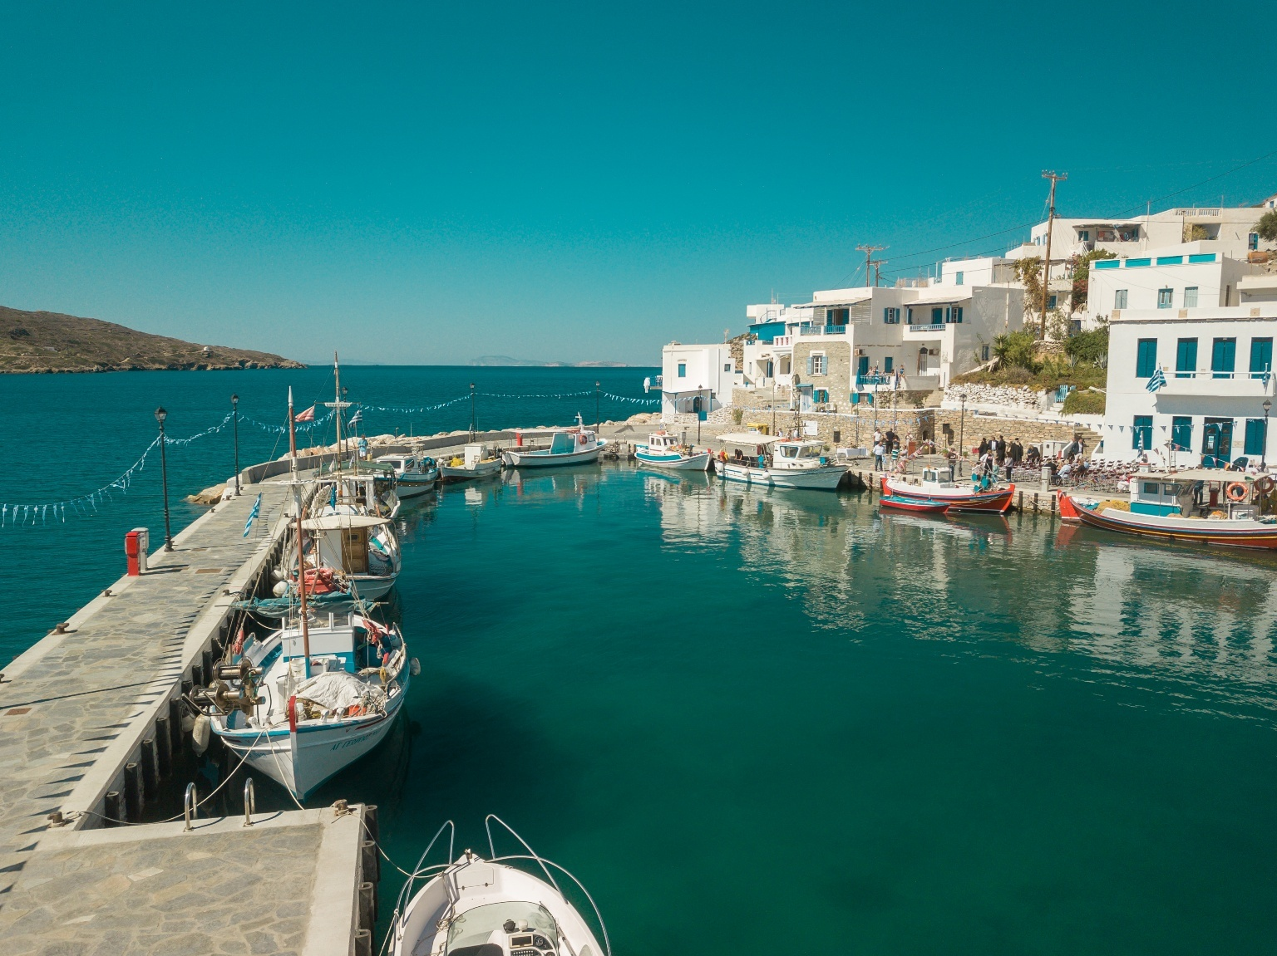

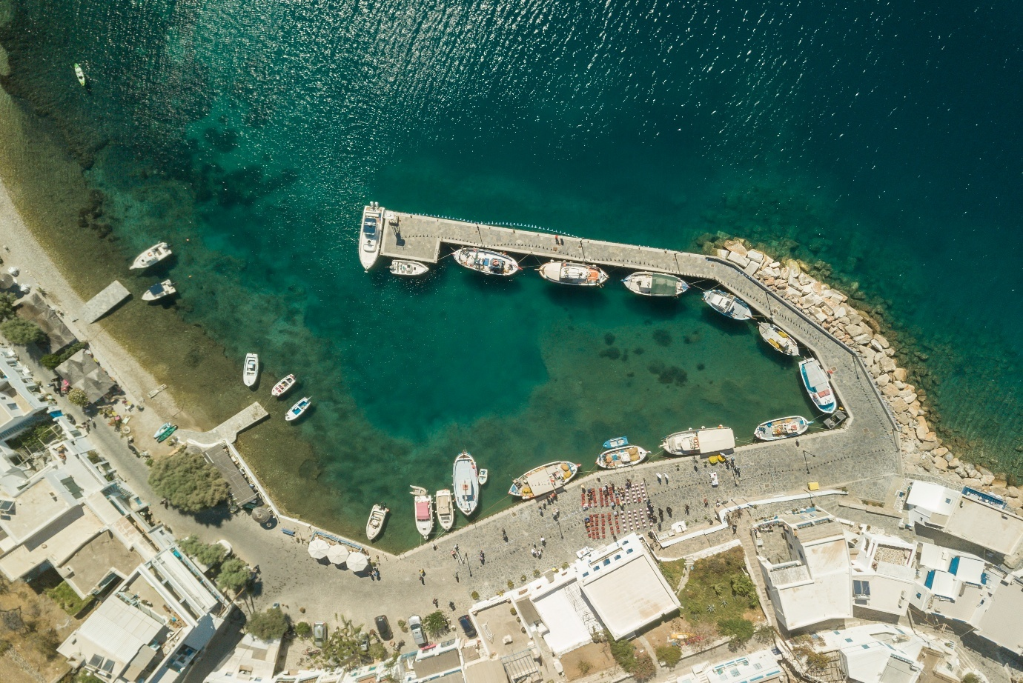

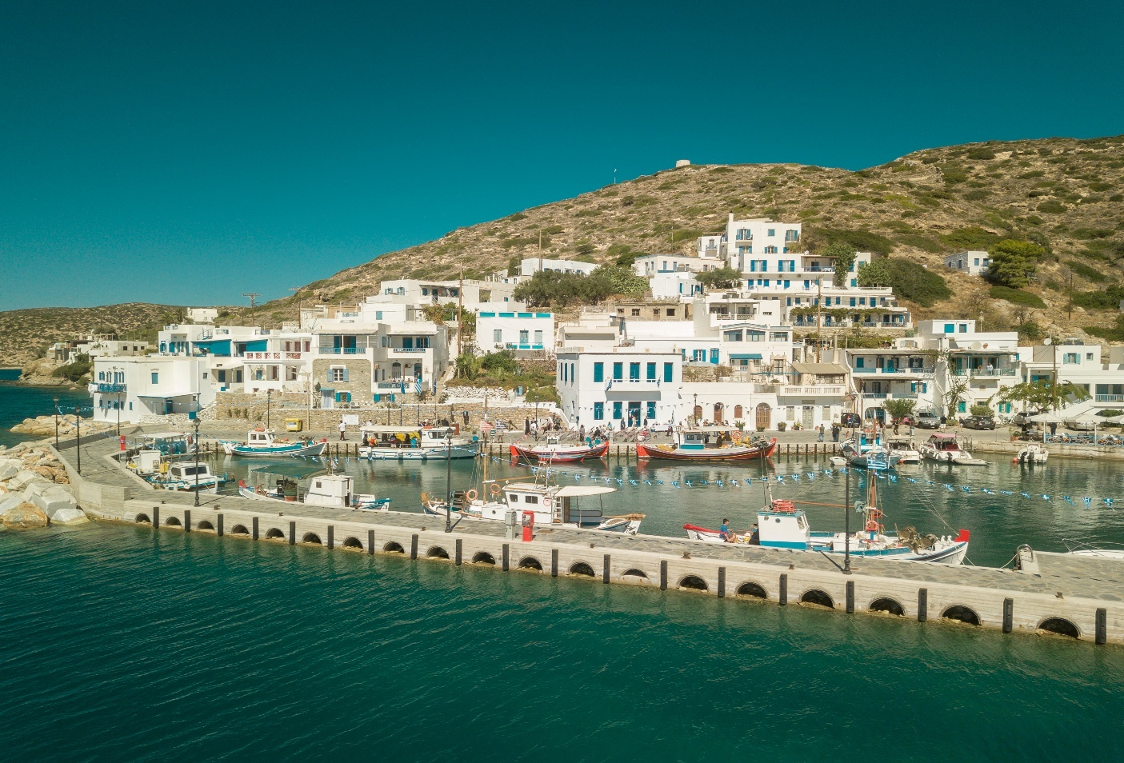

Current Contracts (Under Construction)
YEAR | TITLE | BUDGET - € | CONTRACTING AUTHORITY | CONTRUCTOR
2024- Today | Minor Port Infrastructure Works at Agios Georgios Lichadas (Extension of the Leeward Breakwater of the Fishing Harbor of Agios Georgios Lichadas) | 4.900.000,00 | Regional Authority of Central Greece | UTC TEAM TECHNICAL PC
2024-  Today | Maritime Infrastructure of the Holy Monastery of Iviron | 5.741.330,36 | ERGOMARE SA | UTC TEAM TECHNICAL PC
2024-Today | Pier of the Port of the Holy Monastery of Great Lavra | 7.365.509,64 | Monastic community of Holy Mountain | UTC TEAM TECHNICAL PC

Completed projects of the last decade
YEAR | TITLE | BUDGET | CONTRACTING AUTHORITY | CONTRUCTOR
2025 | Construction Project of the Leeward Breakwater at Nea Krini, Thessaloniki | 420.000,00 | Tekal S.A | UTC TEAM TECHNICAL PC
2024 | Tourist Marina Shelter – ESHADA of Agios Ioannis, Sithonia 9( Hotel AMMOA) | 1.412.903,00 | Tekal S.A | UTC TEAM TECHNICAL PC
2024 | Modernization of the mooring facilities of the 135 Combat Wing | 687.474,85 | Ministry of Defense | UTC TEAM TECHNICAL PC
2023 | Dredging in the inland basin of the port of Porto Rafti | 77,400.00 | Markopoulo Mesogaias Port Authority | UTC TEAM TECHNICAL PC
2022-  2023 | Restoration of operating depths of ports being under the responsibility of Corfu Port Organisation | 290,755.45 | Corfu Port Organisation | UTC TEAM TECHNICAL PC
2022-2023 | Upgrade and Expansion of the existing port Infrastructure of Panayitsa Pier and Underwater Pipe Relocation | 1,816,124.00 | MYKINAI SA | UTC TEAM TECHNICAL PC
2021 | Cutting and hauling of wrecks and dredging in the port of Neo Karnagio, Rhodes Island | 250,000.00 | Rhodes Port Authority | UTC TEAM TECHNICAL PC
2020 | Protection from the corossion of the west coast, of the monastery of Vatopedi | 1.987.412,80 | Monastic Community  Of Holy Mountain | UTC TEAM TECHNICAL PC
2020 | Construction of a piscatorial boat shelter in Xylokeratidi, Katapola, Amorgos Island | 1,725,806.00 | Municipality of Amorgos | JOINT VENTURE«UTC TEAM TECHNICAL PC – KYRIAKOS PAPAGEORGIOU»
2019-2020 | Urgent repair works of the port of Kos caused by the earthquake of July 21, 2017 - Phase B | 4,000,000.00 | Ministry of Infrastructure | UTC TEAM TECHNICAL PC
2019-2020 | Reconstruction of the land area of ​​the fishing shelter Ampelas, Paros and reinforcement with natural boulders | 1,070,495.00 | Municipal Port Fund of Paros-Antiparos | UTC TEAM TECHNICAL PC
2019 | Leasing of a Floating Crane for the installation of a new mooring system in Araxos | 56,000.00 | Ministry of Defense | UTC TEAM TECHNICAL PC
2019 | Leasing of a Floating Crane for the installation of a new mooring system in Chrysoupoli | 58,000.00 | Ministry of Defense | UTC TEAM TECHNICAL PC
2018-2019 | Construction of Buoys Mooring Facilities offshore Araksos Airport | 356,088.00 | Greek Ministry of Defense - Air Force Department | UTC TEAM TECHNIKI IKE
2018-2019 | Construction of Buoys Mooring Facilities offshore Chrysoupoli Airport | 356,080.00 | Greek Ministry of Defense - Air Force Department | UTC TEAM TECHNICAL PC
2019 | Rehabilitation of damages and small techniques from the disasters of Cyclone Zorba in watercourses of the Municipality of Velos-Vochas | 96,774.19 | Directorate of Technical Works of the regional unit of Corinth | UTC TEAM TECHNICAL PC
2019 | Construction of parallel redevelopment projects in the area of Messinos | 240,000.00 | Direction of Technical Projects in Corinthia | UTC TEAM TECHNICAL PC
2019 | Construction of the Underwater Pipeline for the Sewage factory in Menidi Greece | 550,000.00 | AKROS ATE - VLASTARAS ATE | UTC TEAM TECHNICAL PC
2018 | Underwater inspection service of Athletic Port EKKN St. Cosmas - Athens Greece | 23,436.00 | Greek Ministry of Culture - Sports Department | UTC TEAM TECHNICAL PC
2018 | Dredging in the ports of Corfu | 562,846.74 | Corfu Port Authority SA | UTC TEAM TECHNICAL PC
2018 | Repair works in the Port of Kos island after the big earthquake of 2017 | 351,000.00 | Kos Port Authority | UTC TEAM TECHNICAL PC
2018 | Dredging in the Port of Chrysoskalitissa - Crete Greece | 24,800.00 | Chania Port Authority | UTC TEAM TECHNICAL PC
2018 | Dredging in the Port of Souda - Crete Greece | 24,800.00 | Chania Port Authority | UTC TEAM TECHNICAL PC

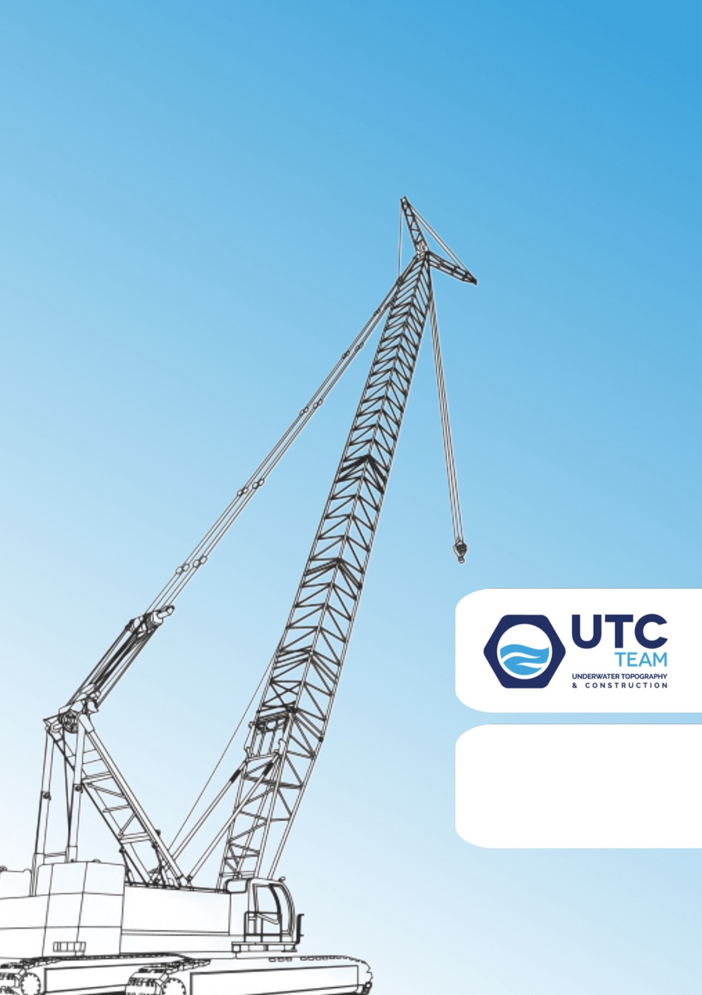
UTC TEAM
Sarantaporou 91a, 15232 Chalandri, Greece
T: 210 6531105 M: 6972828788
E-mail: utcteam.ike@gmail.com

Mathraki, Corfu Ionian Island 2018

Scorpios Island, Lefkada 2022

